vladikvak

Image:

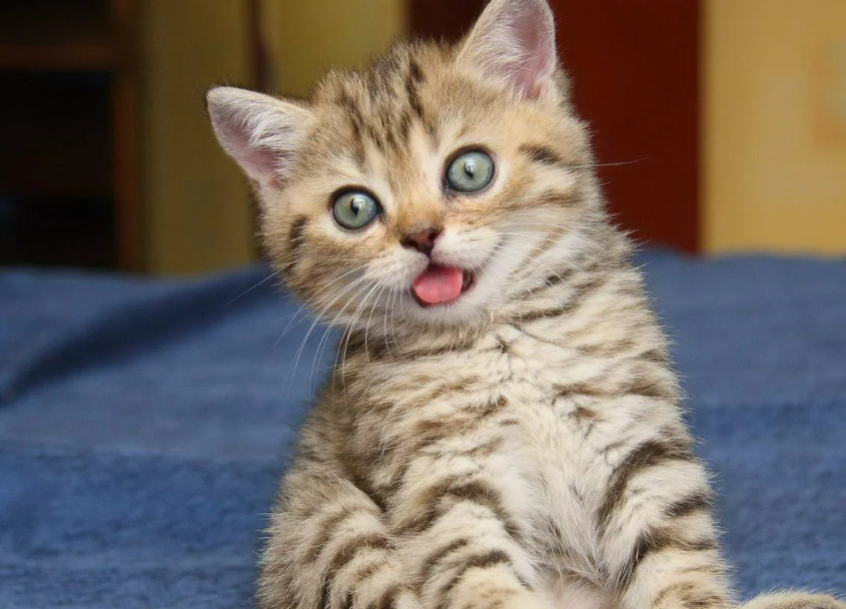

vladikvak

Image:

/

